**DATA ANALYTICS POWERED BY TABLEAU**

**PROJECT TITLE**

**VISUALIZATION TOOL FOR ELECTRIC VEHICLE CHARGE AND RANGE ANALYSIS**

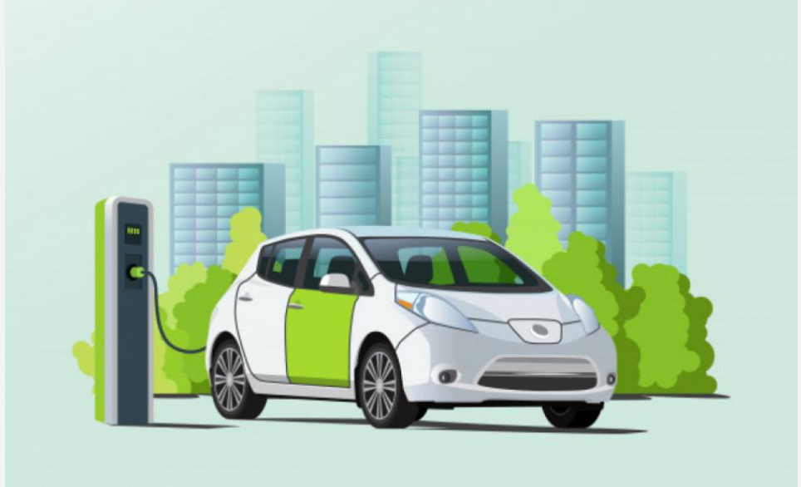

SUBMITTED BY

TEAM ID : **NM2023TMID04116**

TEAM LEADER : **SNEHA K**

TEAM MEMBERS**: AASHIKA J**

**ANCELIN** **A J**

**QUEEN** **BLESSY** **A**

PROJECT REPORT

1. INTRODUCTION
   1. OVERVIEW
   2. PURPOSE
2. PROBLEM DEFINITION AND DESIGN THINKING
   1. EMPATHY MAP
   2. IDEATION AND BRAIN STORMING MAP
3. RESULT
4. ADVANTAGES AND DISADVANTAGES
5. APPLICATIONS
6. CONCLUSION
7. FUTURE SCOPE

**VISUALIZATION OF ELECTRIC VEHICLE**

**INTRODUCTION**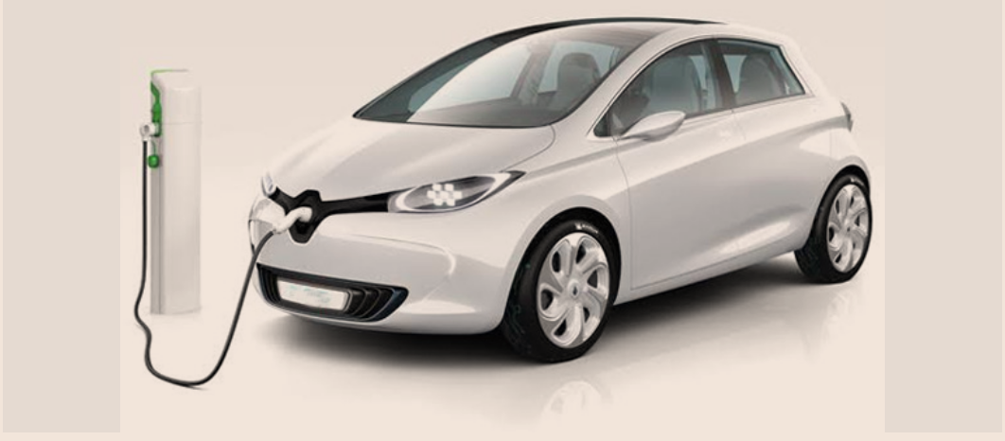

Range is considered as a key parameter of Electric vehicles. Increasing Electric vehicles range is important for acceptance of electro mobility. Battery capacity is the main parameter influencing Electric vehicles range. In order to batteries are the most expensive part of Electric vehicle is it suitable to focus on other parameters such as weight, aerodynamic, drag coefficient or correct size of motor. Those factor range was created for better accuracy was used real driving cycle.

**PROBLEM**

To Charging and Range of Electric Vehicle.

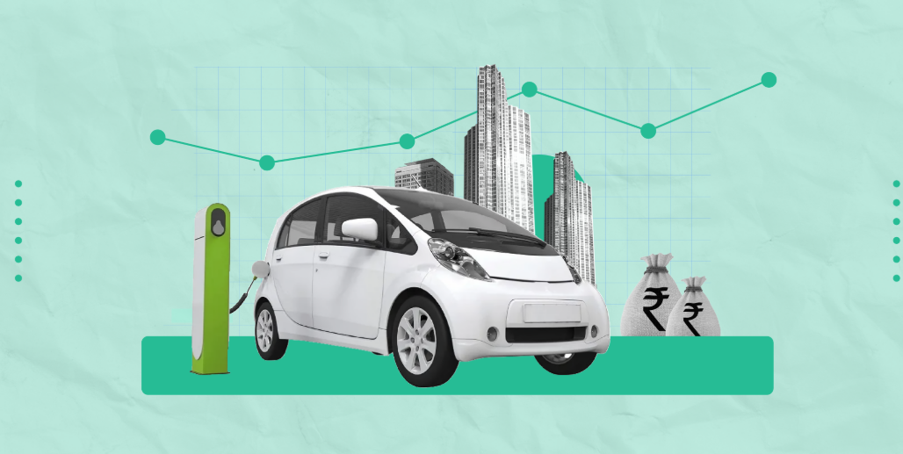

**EMPATHY MAP**

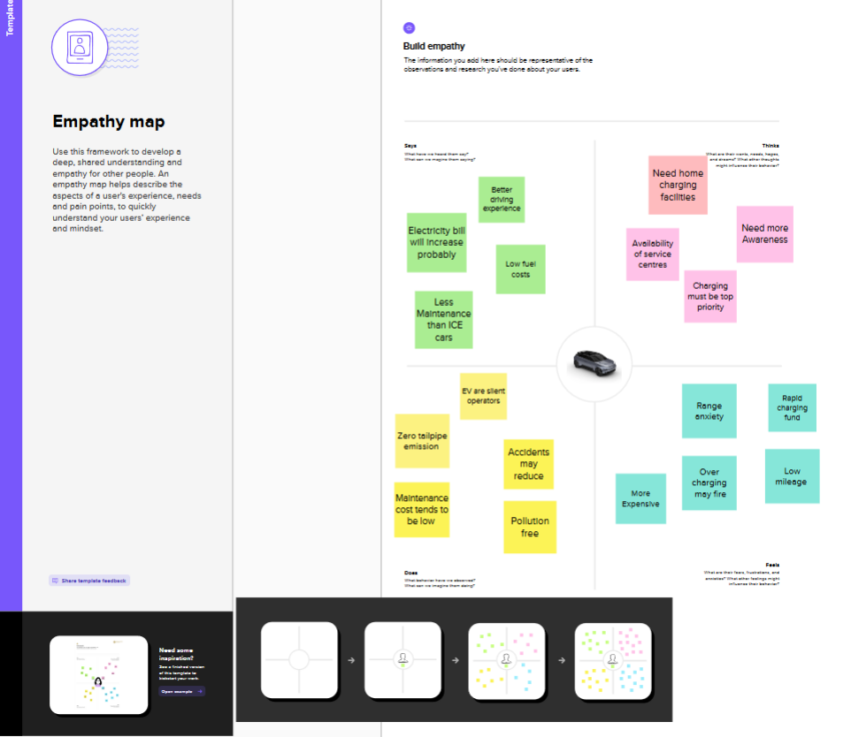

**IDEATION AND BRAIN STORMING**

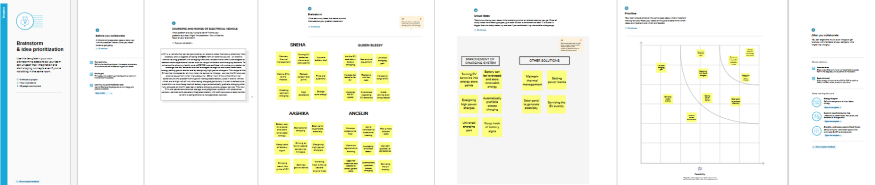

DASHBOARD

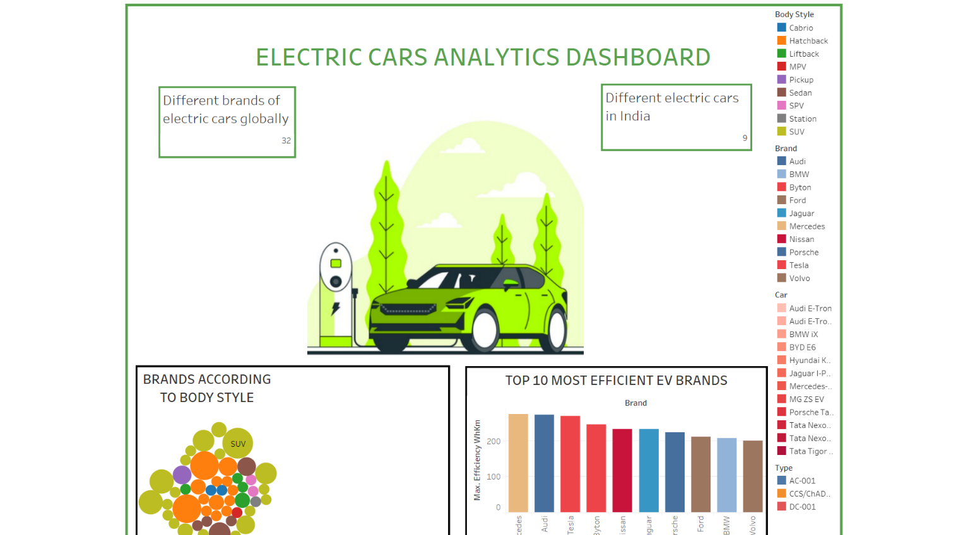

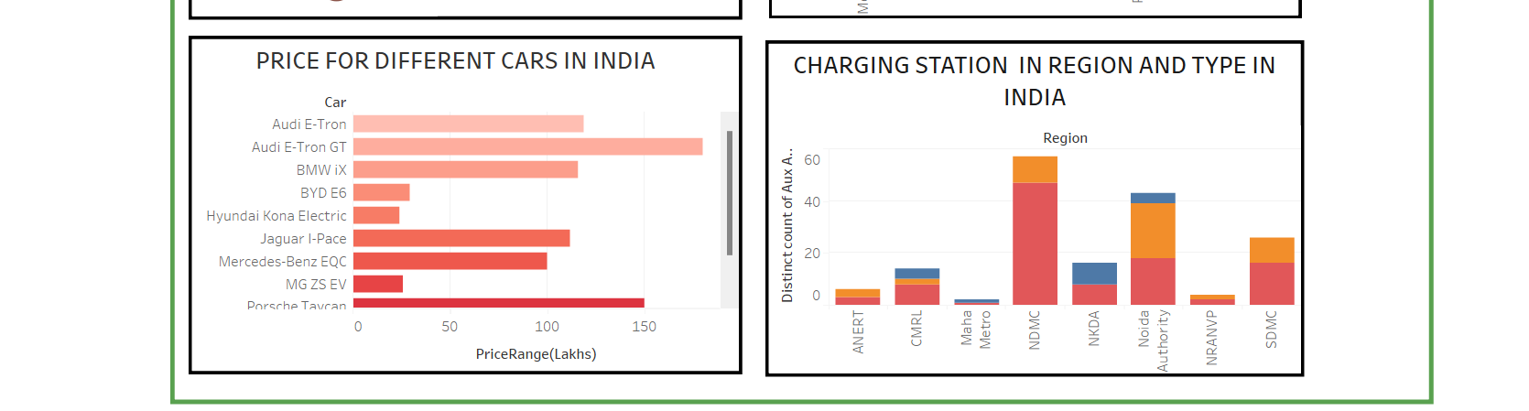

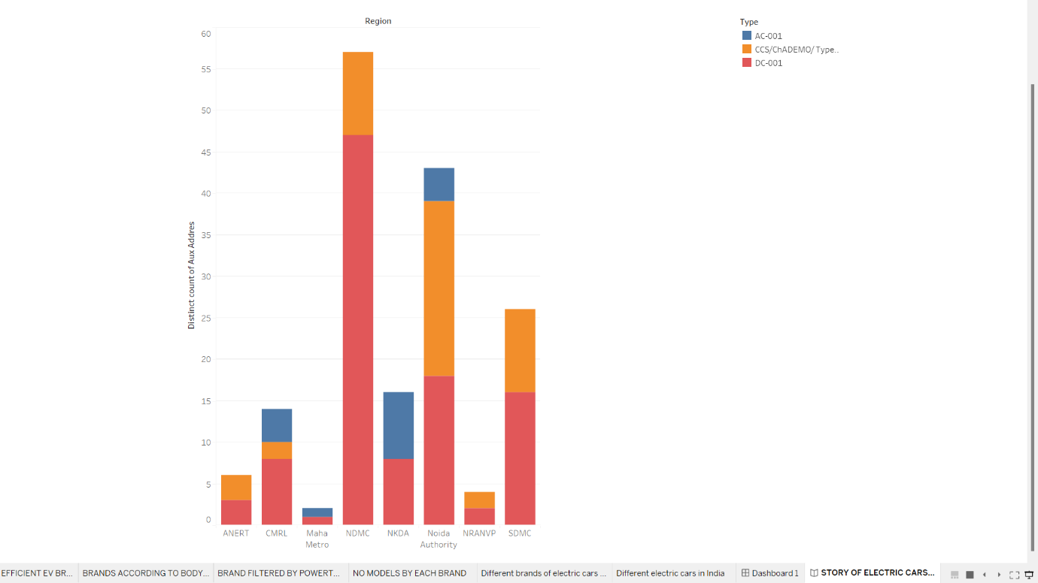STORY

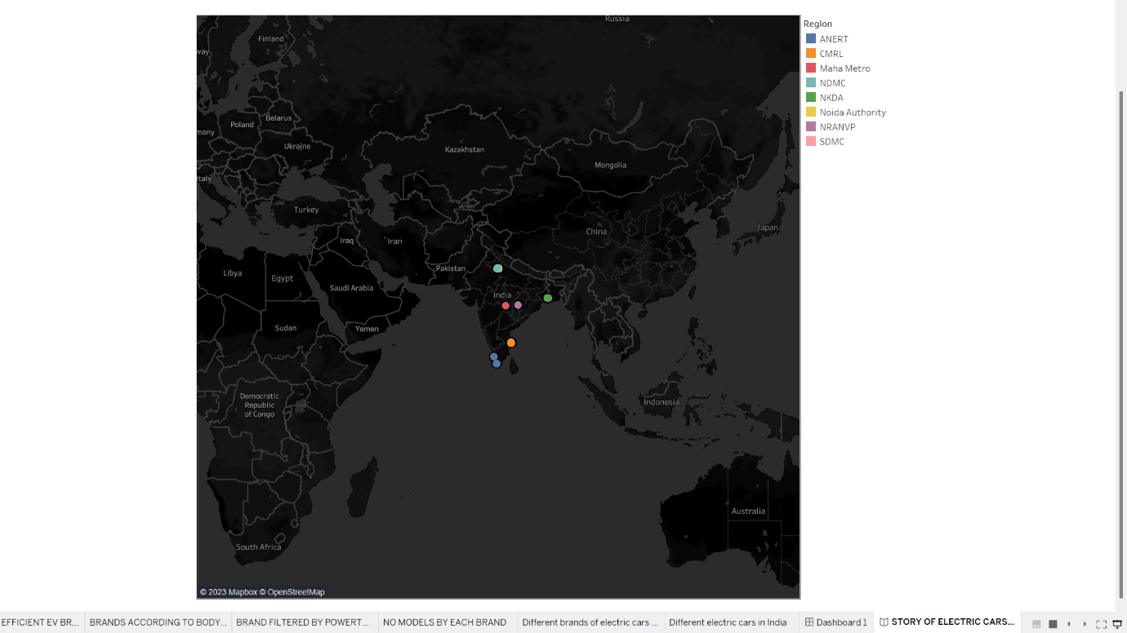

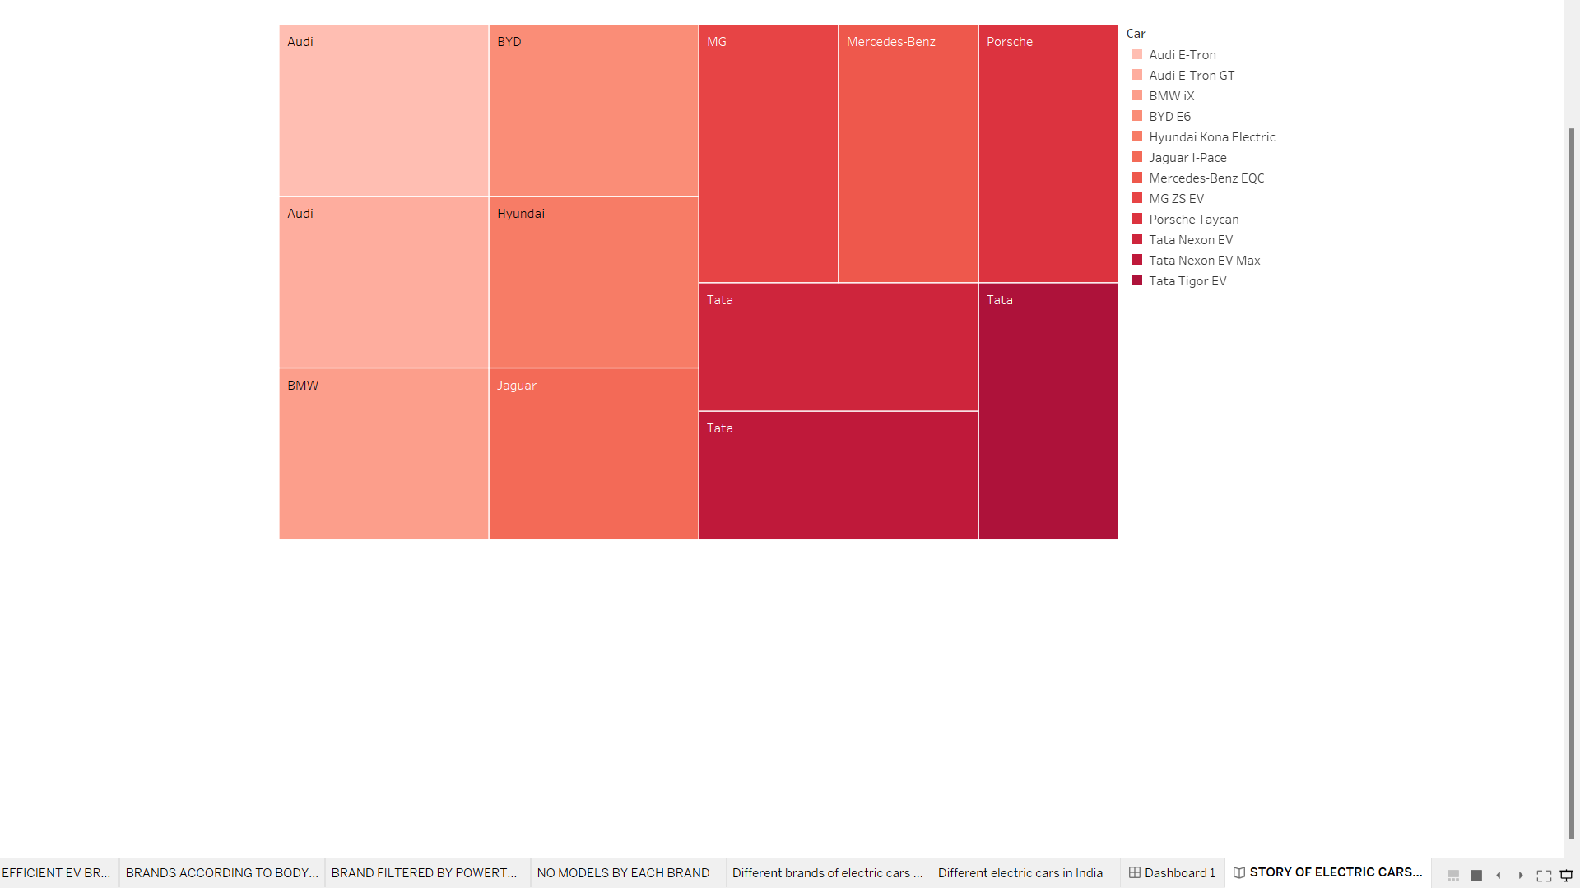

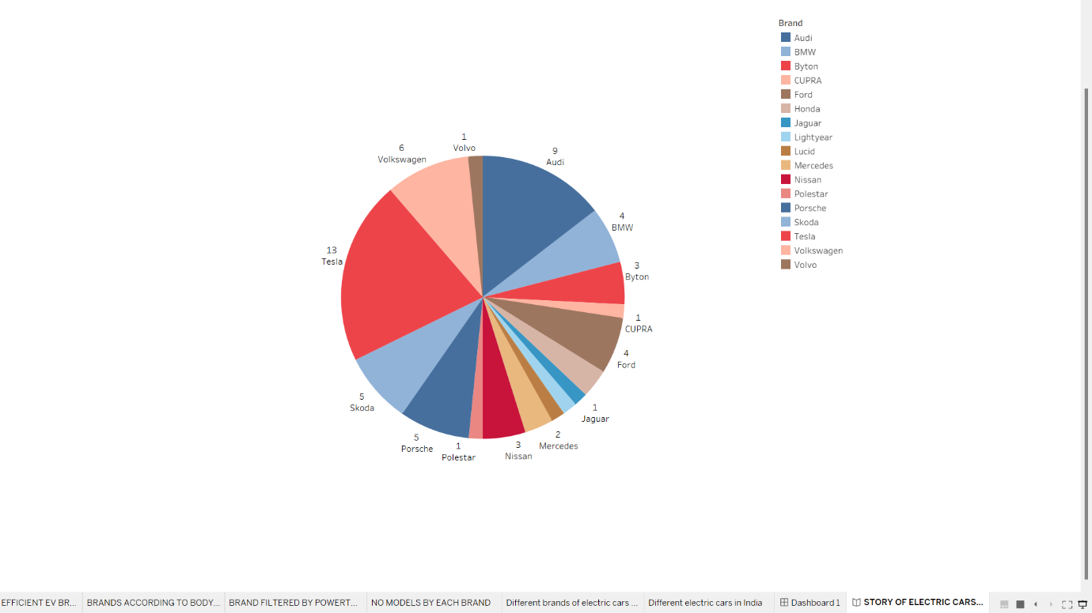

WEB INTEGRATION

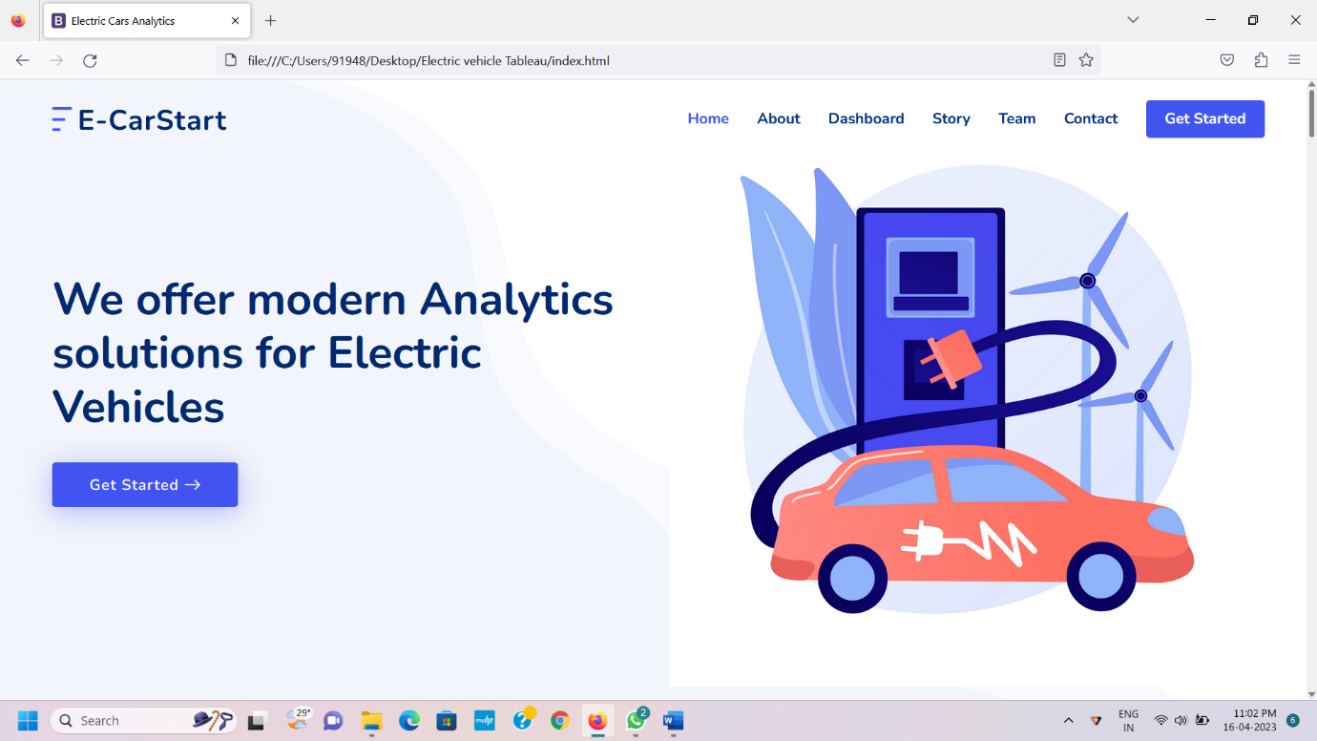

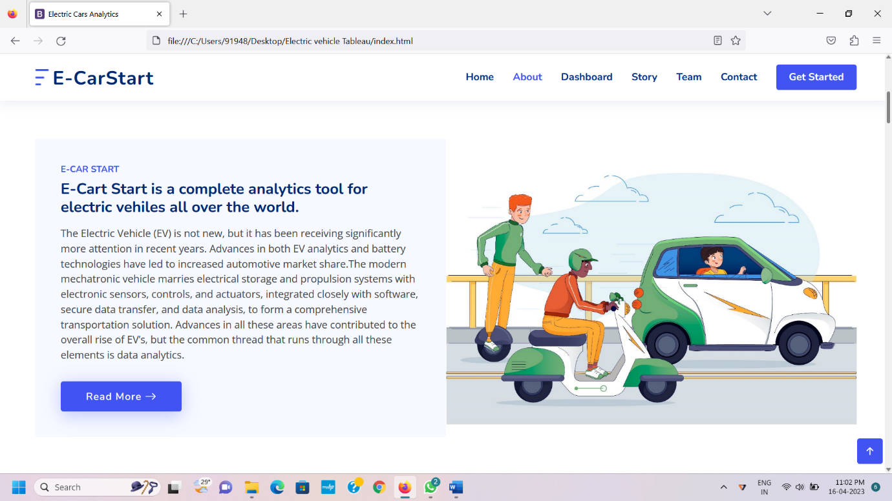

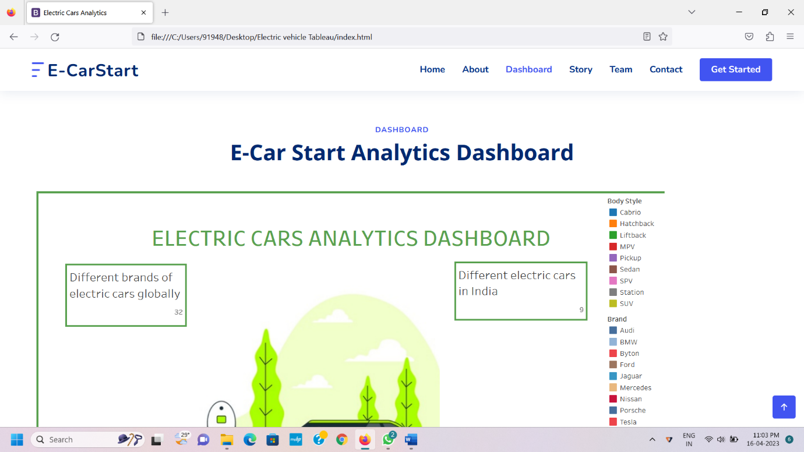

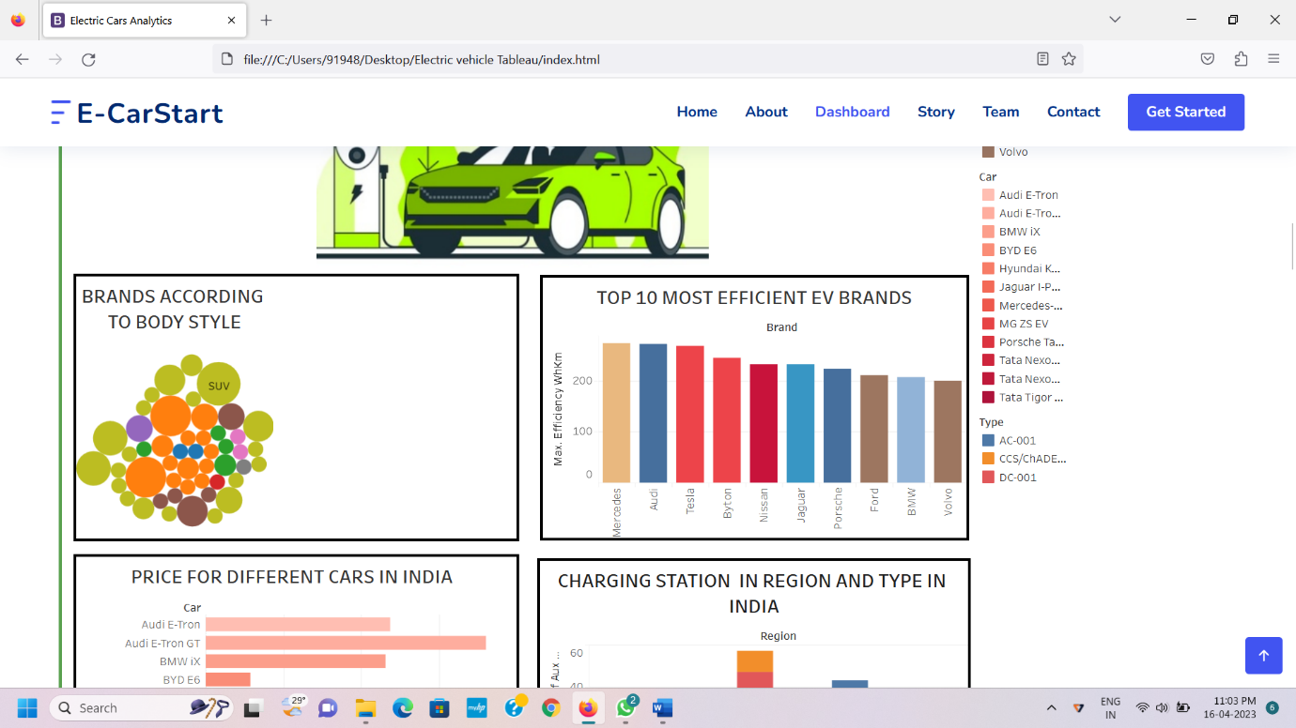

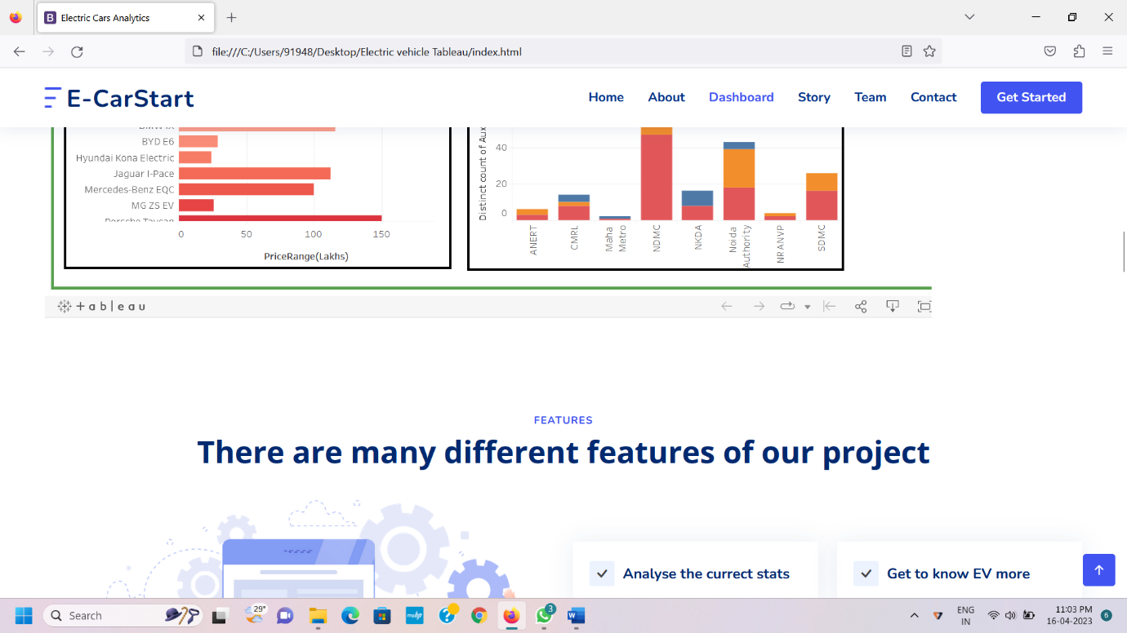



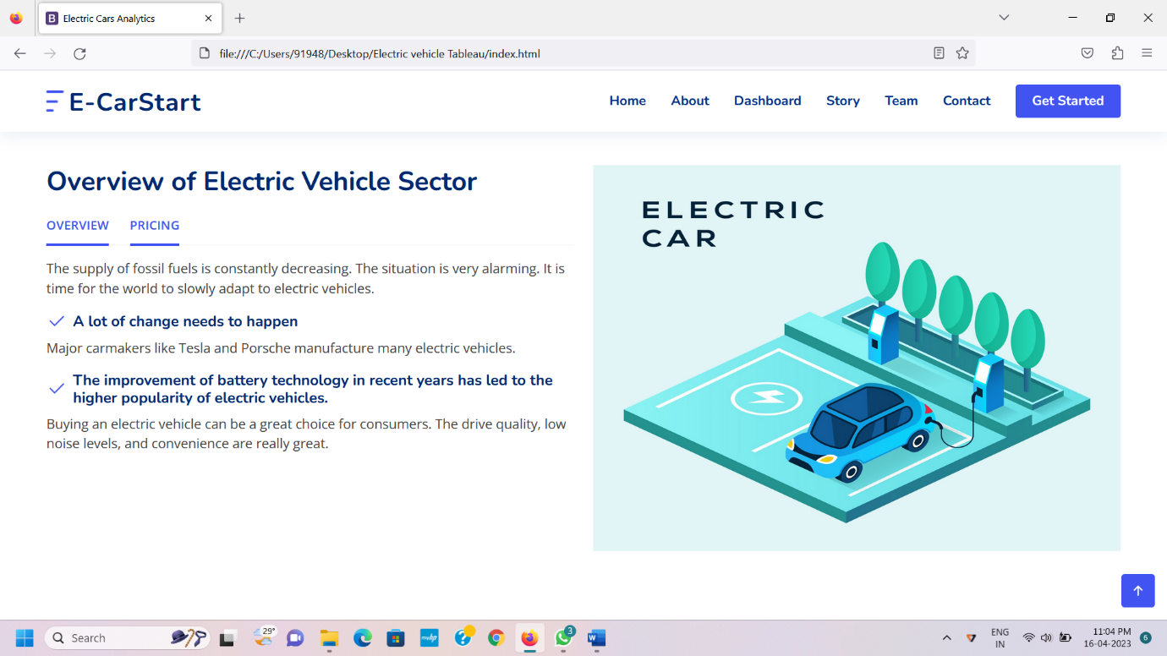

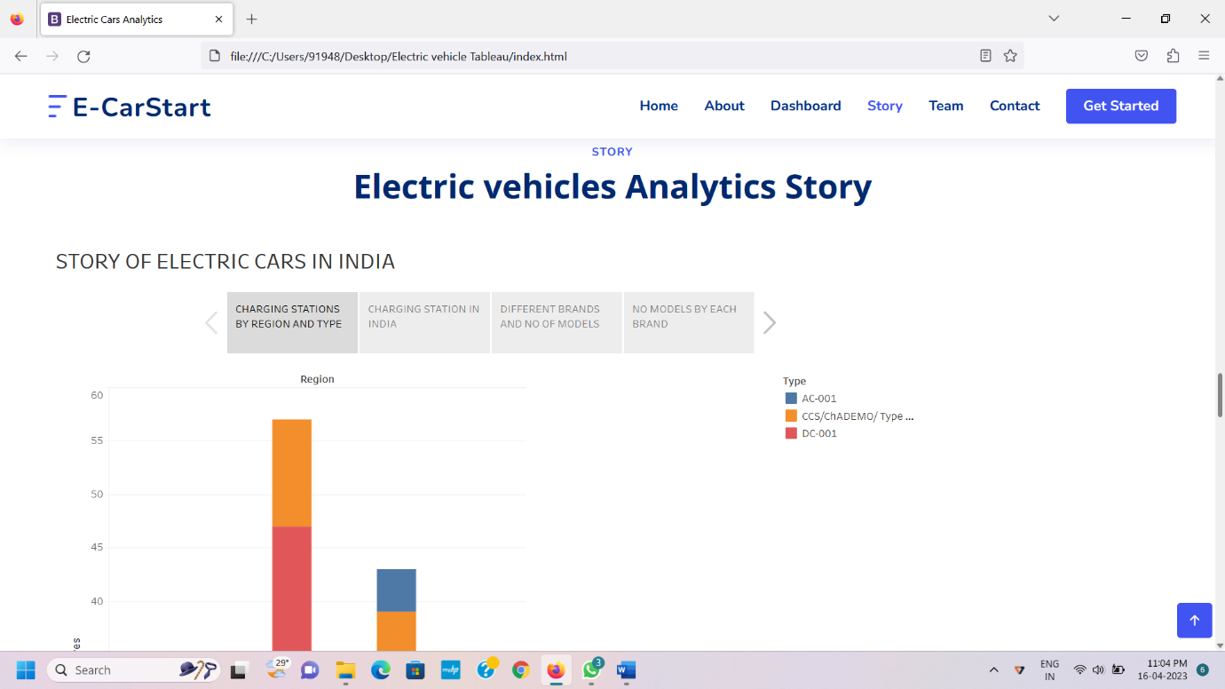

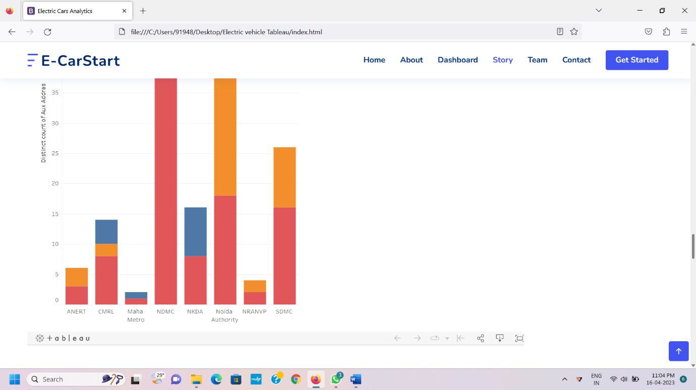





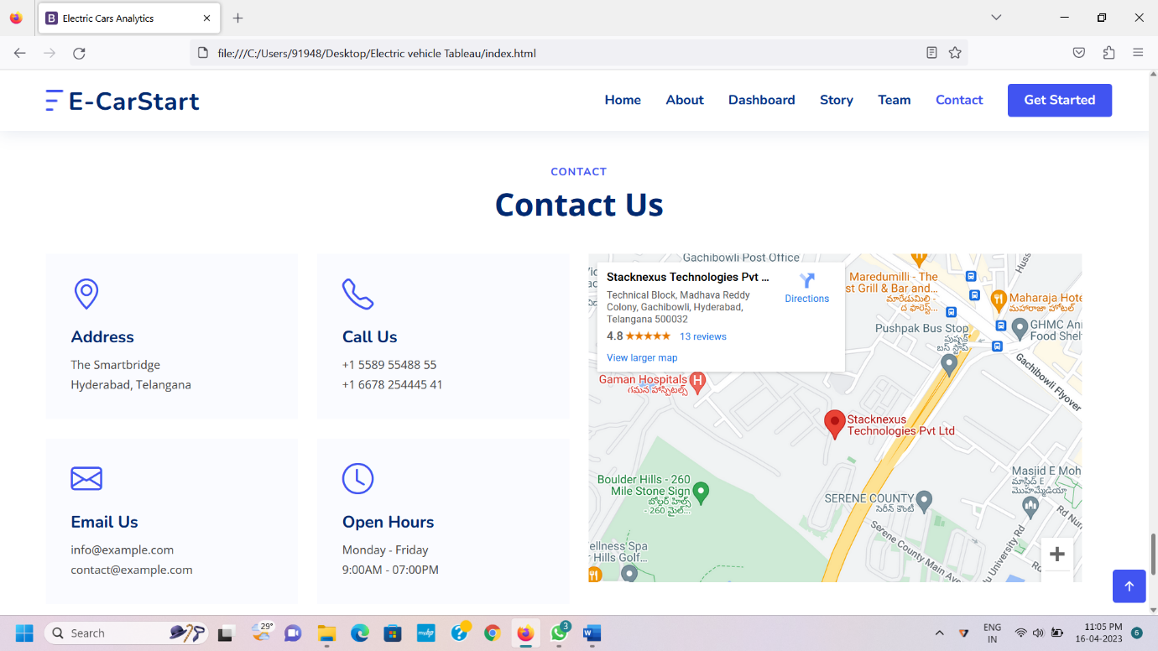

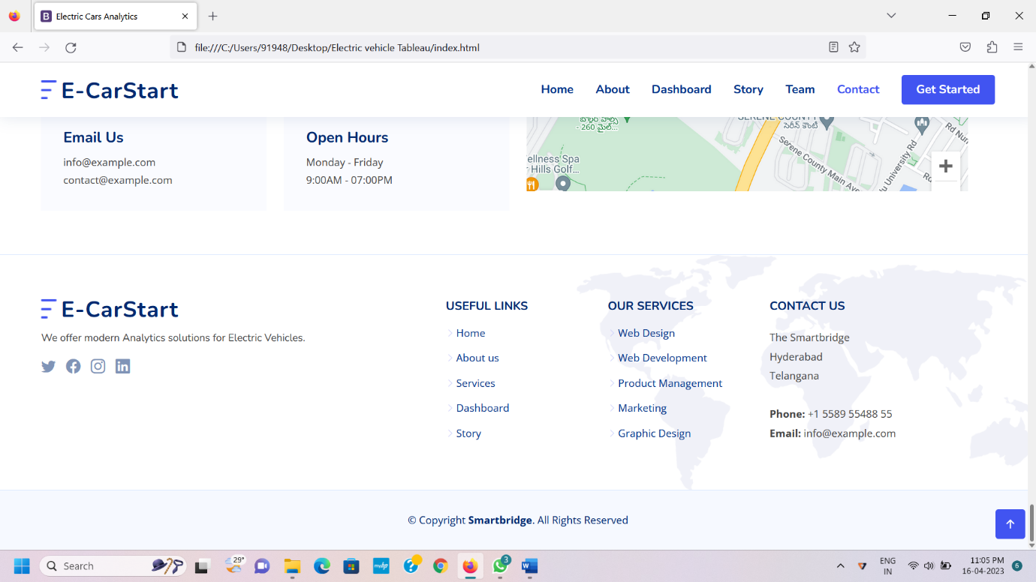

ADVANTAGES AND DISADVANTAGES

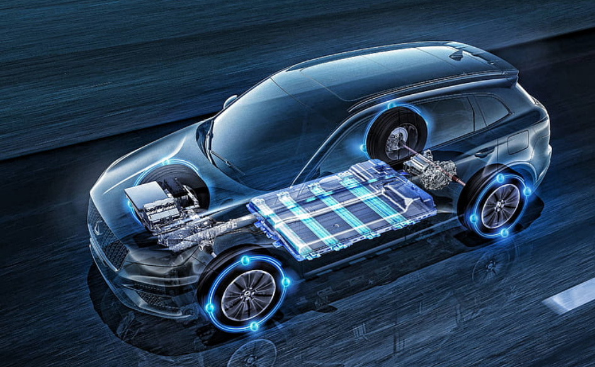

**ADVANTAGES**

* Driving Electronic Vehicles can save you more than 70% of Fuel cost.
* Electric Vehicles are silent operators.
* Running on EV means Good Bye to “Exhaust Gases”, say Hello to “Clean Air”.
* Better performance and speed.
* No maintenance cost.

**DISADVANTAGES**

* The major disadvantage of Electric Vehicle is the battery has to be charged regularly.
* Short Driving Range – Range Anxiety.
* Over charging of Electric Vehicle may fire.
* Electric Vehicle require long charging time.
* Often, they are more expensive than normal cars.

APPLICATION

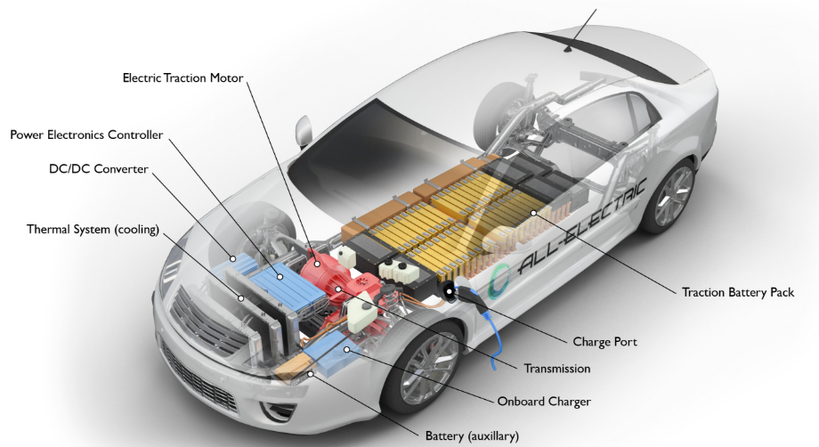 Electric Vehicles use electricity to charge their batteries instead of using fossil fuels like petrol or diesel. Electronic Vehicles are more efficient and that combined with the electricity cost means that charging an Electric Vehicle is cheaper than filling petrol or diesel for your travel requirements.

CONCLUSION

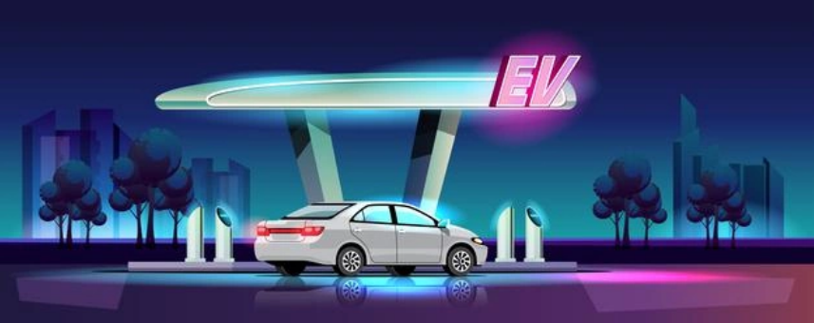

Charging Stations can be increased once the sales of Electric Vehicles increase. This could be achieved by customer awareness about Electric Vehicles. As the use of the EV’s increase, OEM’s can also bring varieties of products in low range of prices.

FUTURE SCOPE

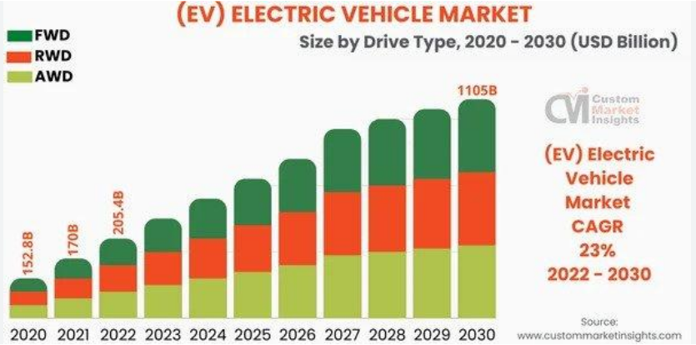

India is the world’s Third Largest EV Market. The Global Market for Electronic Vehicles is growing continuously at a compounded annualized growth rate (CAGR) of 21.7%. It is expected to grow from 8.1 million units to 39.21 million units by 2030. This exponential growth is being driven by various factors, concerns for pollution.